OPEnS eDNA Sampler Function (This falls under “Hardware Description” Section)

Outline:

* General Specs/Introduction
  + 24 Filter Housings capable of holding 47mm samples.
  + Sampling Rate (1L sample takes 10-15 minutes with a 5um filter.
  + Cross Contamination Value?
  + Temperature, Flow, and Volume measurements taken for researchers.
  + Pressure data taken in for safety measures and general sampler operation.
* Hydraulic Layout of the sampler
  + Pair with next section
* General Sampling Procedure
* Other functions of the sampler
* Electronics
* Layout of the Browser Application
* Outline of the SD Card (Include in the code upload portion?)

1st Draft:

The eDNA sampler we have developed is an autonomous multi-sampling device that collects eDNA samples from water via 47mm filter holders and provides a non-invasive, safe, and autonomous means of DNA collection. The sampler can hold 24 of these filter housing and are designed to be easily replaced and reusable. The sampler is controlled by a custom logic board with an Adafruit M0 Feather Wi-Fi microcontroller loaded with a webserver to act as the interface for the sampler’s operations. This webserver hosts a browser application which is used for real-time monitoring, scheduling tasks, and data logging for time, pressure, temperature, flow, and sample volume. This data is located stored onto an SD Card for later data analysis.

(Insert Image)

### Hydraulics

The hydraulics of the sampler can be roughly split into the following sections:

* Inputs
* The Pump and Input Source control
* The Lower Hydraulic Rail
* The Filters
* The Upper Hydraulic Rail/Output

There are three inputs into the sampler: one for air, one for preservative, and one for water. The preservative input is connected to a hydration bladder where the preservative of choice can be stored. The water input has a prefilter at the front end of the tube to prevent debris from entering the sampler. Three valves are used to control the flow from these inputs with the air preservative being regulated by a solenoid valve and the water being controlled by a ball valve. These three valves connect into a single tube connected to the input of the peristaltic pump.

The pump is capable of 400ml/min of flow under ideal conditions. The output of the pump connects directly into the Lower Hydraulic Rail.

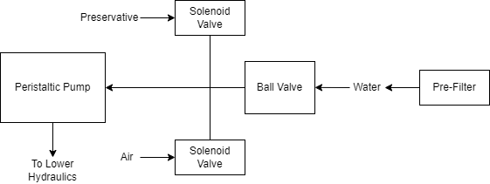

The Lower Hydraulic Rail consists of 24 solenoid valves connected parallel to each other which controls which filter liquid flows through. The valves are split into two sets, one on each side of the sampler. In between these two sets is a M32JM-000105-100PG pressure and temperature sensors. The temperature is logged for later use and the pressure is used for monitoring, stopping an operation if the pressure exceeds a certain margin. At the end of the Lower Hydraulic Rail is another solenoid valve which allows for the lower hydraulics to be purged of their current contents when necessary.

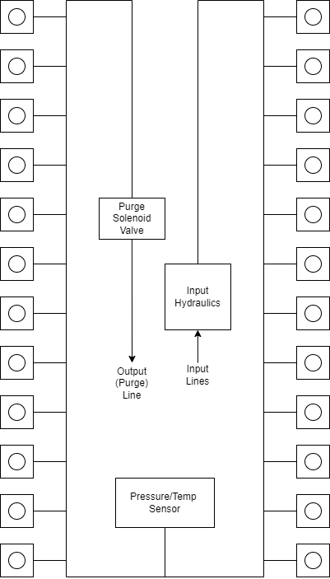

After the solenoid valve there is a tee connection that goes to a one-way check valve and a modified Advantec filter. The one-way check valve allows air into the solenoid valve that opens when the pump runs backwards. The Advantec filter is modified with a CPC quick disconnect and a one-way check valve. The one-way check valve is connected to the Upper Hydraulics and is used to prevent liquid from going backwards through the filter. The Upper Hydraulics simply connects the output of all the filters to one central line that goes through a flow meter and out of the sampler.

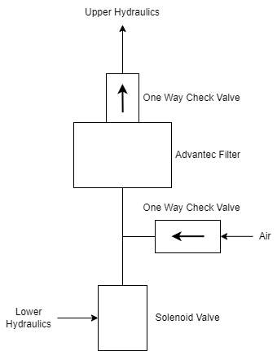

### Sampling Procedure

Having worked on multiple iterations of the sampler, we have decided to go with a 13-step sampling sequence that helps reduce cross contamination significantly. This sequence can be split into 9 unique steps: Idle, Prefilter Clear, Flush, Offshoot Clean, De-pressure, Sample, Preservative Flush, Preservative, Air Flush, and End.

The Idle state is the default state of the sampler. This is where the sampler waits for a signal from the RTC to move to the first/next state of the Sampling Sequence. If the sampler is not in sleep mode, this is when a client would interact with the UI to do a handful of tasks such as setting up a Sampling Schedule or using the other task utilities. If the sampler is in sleep mode, then only the RTC and supporting circuits are powered. This means there is no way to interact with the sampler without exiting sleep mode.

Once the RTC sends the signal to start a sample procedure, the sampler enters the Prefilter Clear (PC) state. In this state, the purge and input ball valve are opened, and the pump is run in the backwards direction. This will allow for air to flow from the purge and out the input line. This is used to clear the prefilter of anything that might be clogging it, such as accumulated debris. This state runs for __ seconds, before moving onto the next state.

The Flush state and the proceeding Offshoot Clean (OC) state are used to prepare the lower hydraulics before the Sample state. The Flush state starts with the purge valve and the ball valving opening, then the motor starts to run in the forward direction. This fills the lower hydraulics with sample liquid and clears out/dilutes and liquid that remained from previous sample. The Flush state runs for the time specified when the Sampling Schedule is created. We recommend a Flush time of 6 minutes.

The OC state closes the purge valve and opens the filter valve (for the filter which is about to be used. The pump runs backwards for a few seconds. This clears anything that might be in the tube between the valve and the filter (what we refer to as the offshoot). The Flush state is run one more time before moving to the Sample state.

Like the name suggests, the Sample state is where the system pushes the sample water through the filter. This is done by opening the Filter and Ball Valve and running the pump in the forward direction. The system moves to the next state when the target Sample Volume is reached. This volume is measured by a Flow Meter on the filter output line. Ideally, the state is terminated when the target volume is reached. There is an additional condition that will end the Sample state and that is the Sample Time. This time cutoff was added since the filter clogs and the flow rate decrease rapidly during the sample process. To prevent the sample state running for too long, the time limit was implemented. Both conditions are set during task scheduling. Since the pressure greatly increases due to the clogged filter, the de-pressure state is used to reduce the pressure in the lower hydraulics to ensure that the valves can operate consistently.

Preservative Flush and Preservative

The Preservative Flush (PF) and Preservative (P) states are the next states in the sequence after the de-pressure state. The PF state is nearly identical to the Flush state except the Preservative input valve is used instead of the ball valve. The goal of this state is to saturate the lower hydraulics with preservative, preventing additional sample water that may have been stored in the lower hydraulics from going through the filter. If this water was allowed through the filter, then the Sample Volume would be inaccurate by the end of the sequence. The P state is like the Sample state except preservative is the input fluid instead of sample water. This state runs for a time specified by the user during scheduling.

After the P state, another Flush and OC state runs to purge the leftover preservative in the lower hydraulics. After these two states, an Air Flush (AF) state is run which is identical to the Flush and PF states but uses the air valve as the input instead of the other two inputs. This ensures that any liquid that is in the lower hydraulics is purged.

After the AF state occurs, the system sets an RTC alarm for the time of the next sample. The system then moves into Idle and if the system was in sleep mode, then the system will go into its low power state.

### Utilities

The HyperFlush utility runs water through every filter sequentially for a few seconds per filter. This is mainly used for cleaning out the system after a sample task (i.e., a set of 24 samples) to prevent any unwanted cross contamination. This utility can also be used to test the basic functionality of the sampler, as nearly every component is activated during this sequence.

The Preservative Air Purge (PAP) utility turns the pump on and opens the alcohol valve for 10 seconds. This runs some alcohol through the system and removes air bubbles from the alcohol bag. Often it helps to use this utility multiple times and to tilt the Preservative Bladder so that the air is near the port.

The Update RTC utility is needed to make sure that the time on the sampler matches your local time, so scheduling a task will remain accurate. Whenever the system is fully depowered (ie the battery is removed), or when new code is uploaded to the microcontroller, the RTC will need to be updated. It is also recommended that the RTC is updated when there is a daylight-saving change, or when you move between time zones.

The Reset Valves Utility is used when valves have been sampled that you want to be sampled again. This is required since the system ‘locks’ the filter valves when they have been used in a sample, this prevents samples from being corrupted accidentally. The code does not let you sample a valve multiple times without being reset to prevent messing up a sample. It is important to note that this utility will reset all valves, not a specific one.

### Electronics

(Insert Image)

The PolyWAG Sampler is designed with a custom electronics control board that can be split into 8-10 blocks with an Adafruit Feather M0 at its core. These blocks consist of the microcontroller/Wifi Block, Power, RTC, and sleep control blocks, and the output blocks consisting of the Shift Register, Pump, and Ball-Valve H-Bridge Blocks.

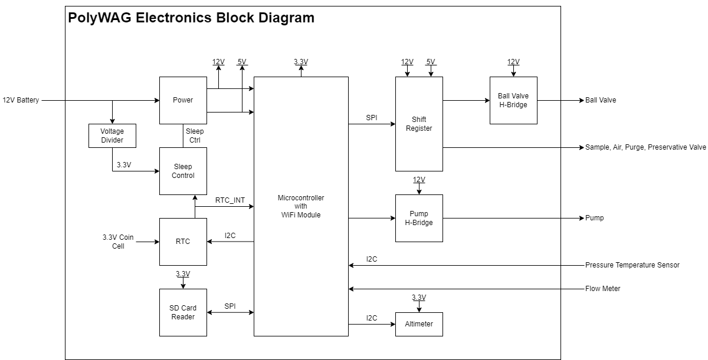

The power block consists of a reverse polarity current (RPC) circuit and a voltage regulator circuit. The RPC Circuit was added to protect the 12V battery from current flowing backwards through the system. While the battery has its own protection circuits, they lock the battery in the case of a short and need to be reset using the battery charger. The RPC circuit was added to prevent any “permanent” power loss while in the field. The voltage regulator circuit is a 12V to 5V regulator with an enable pin that connects to the sleep control circuit. This is used to save power during long term deployments.

The RTC and sleep control circuit are used to keep track of time and to save power respectively. The sleep control circuit controls the output of the power circuit and is constantly being power by a simple voltage divider circuit. It is basically a Flip Flop circuit that is reset when the RTC triggers an interrupt. The RTC circuit is used to keep track of the time between samples and is powered by a coin cell while power is off. This allows it to keep accurate track of time and signals an interrupt when its internal alarm is triggered. This interrupt is used to both turn power back on and to inform the microcontroller that it is time for a sample. If noise causes the sleep control circuit to reactivate power, the microcontroller will see that the RTC did not trigger the interrupt and will fall back into power saving mode.

(Shift Registers and H-Bridge)

(SD Card and Sensors)

(Microcontroller and other notes)

### User Interface

(Introduction)

(UI Main Page)

(Breakdown of the UI)